**Step 1: Creating a Database:**

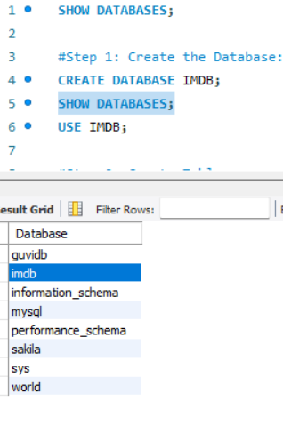

**Step 2: Create Tables:**

**Movies table creation:**

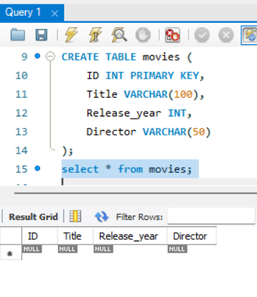

**# Insert Sample Data**

**# Adding a Movie:**

**Media Table (Movies can have multiple images/videos)**

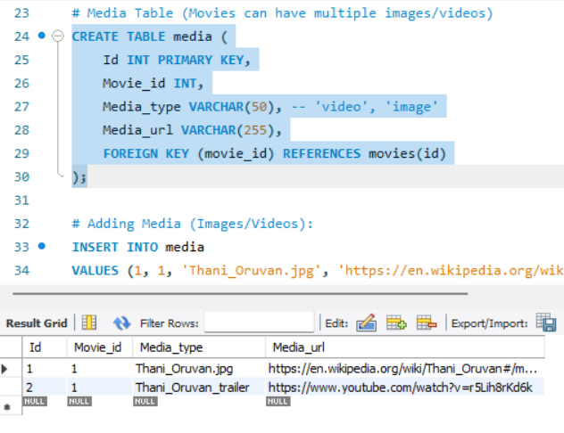

**# Adding Media (Images/Videos):**

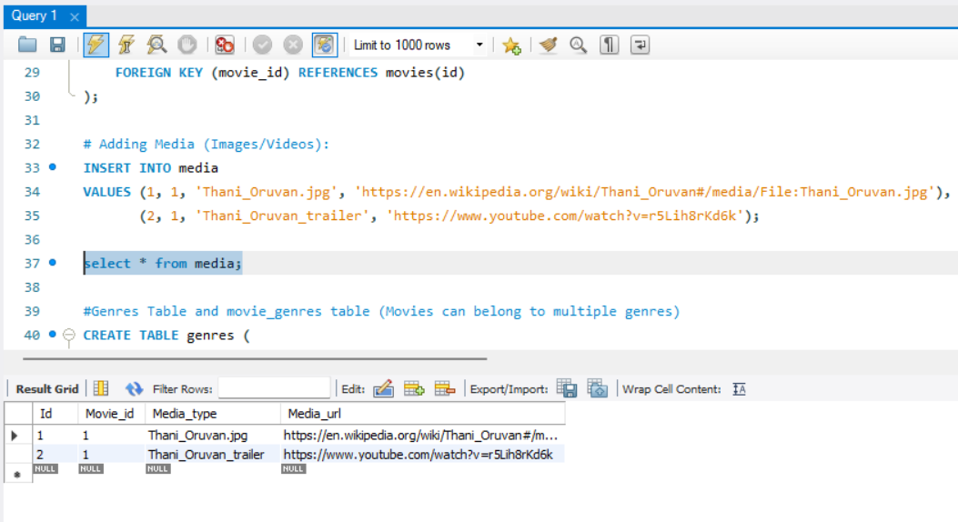

**#Genres Table and movie_genres table (Movies can belong to multiple genres)**

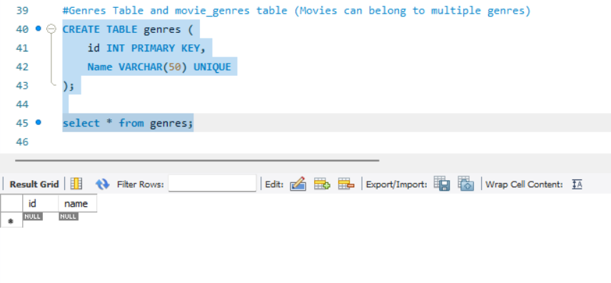

**Movie_genres table:**

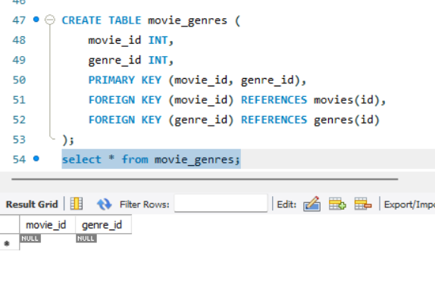

**#Adding Genres & Linking to Movie:**

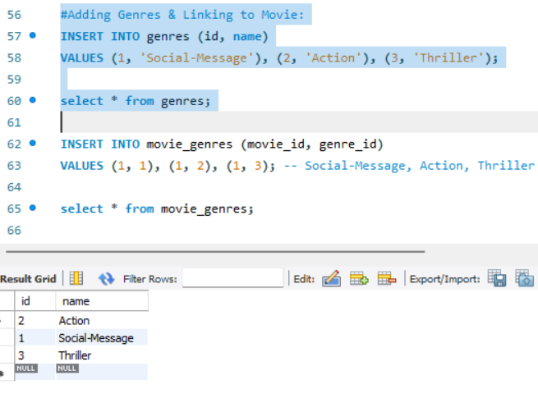

**Users Table (Reviews belong to users)**

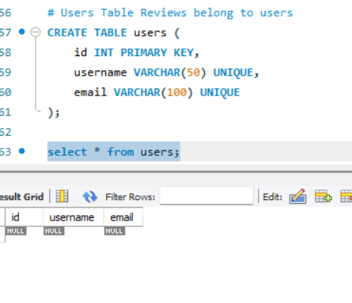

**Reviews Table (Movies can have multiple reviews)**

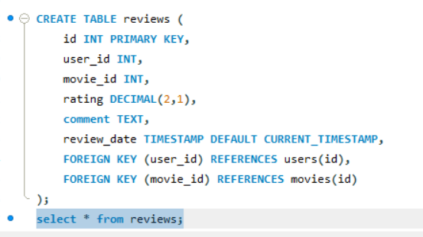

**Adding Users & Reviews:**

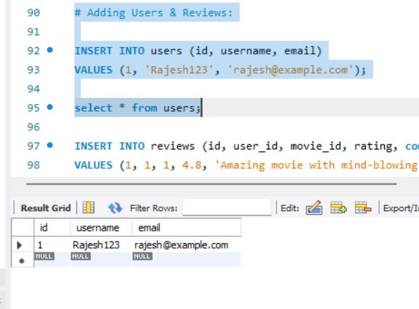

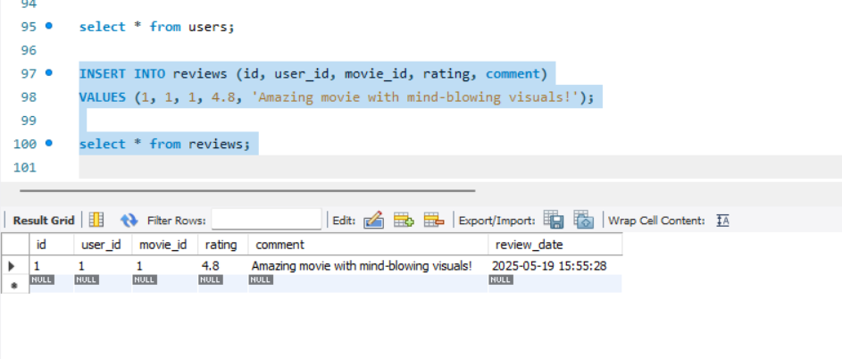

**Artists Table (Artists can have multiple skills)**

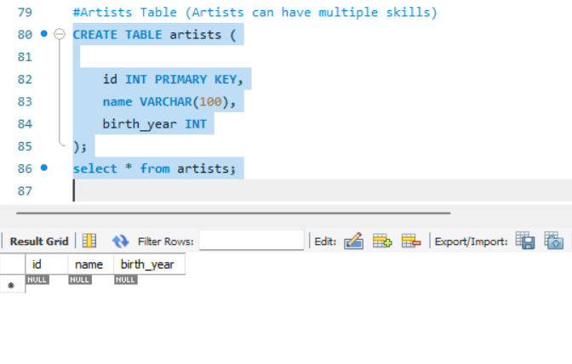

**# Skills table creation:**

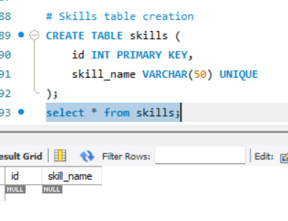

**Create artist_skills table:**

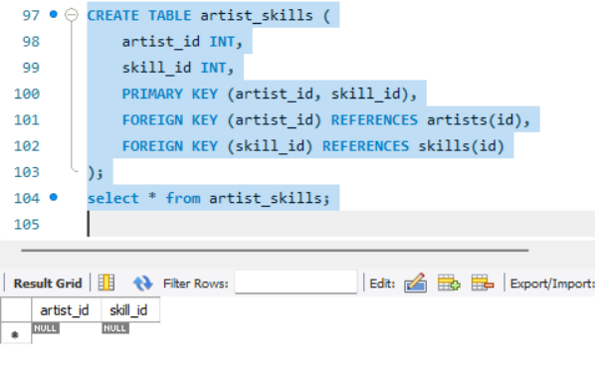

**Adding Artists & Skills:**

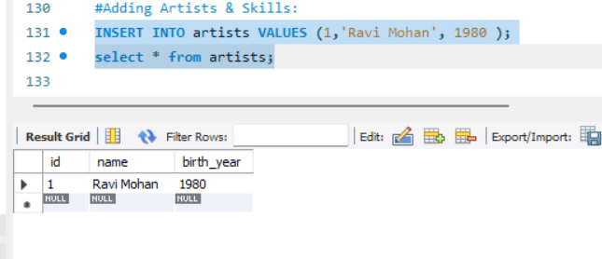

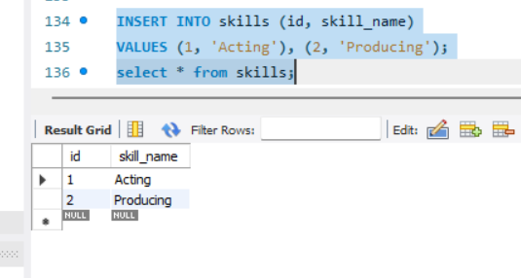

**Artist Roles Table (Artists can perform multiple roles in a single film)**

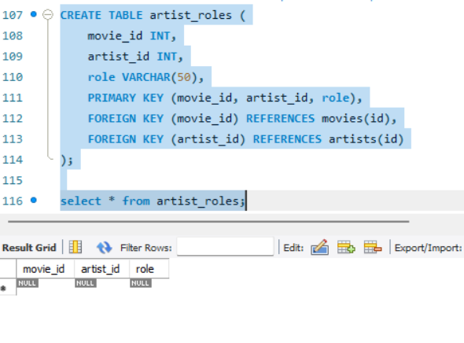

**Assigning Roles in a Movie:**

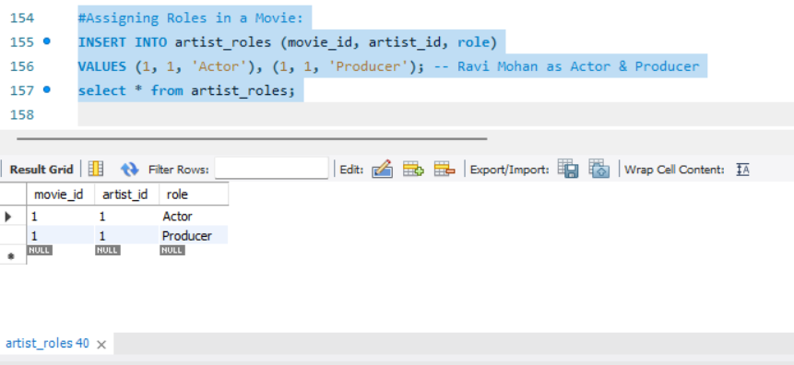

**Retrieval Queries: Get All Media for a Movie**

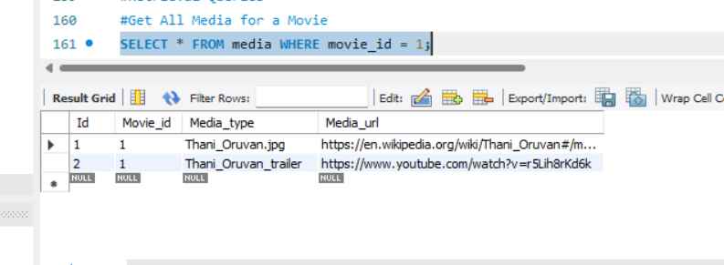

**Get mediaURL from media table:**

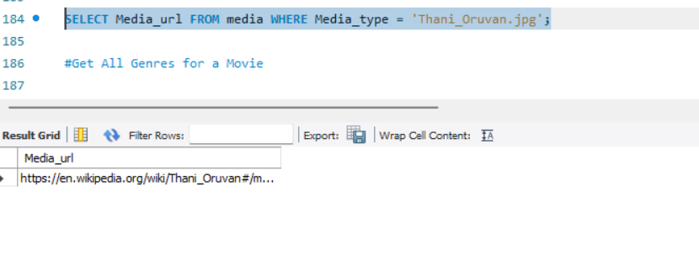

**Get All Genres for a Movie**

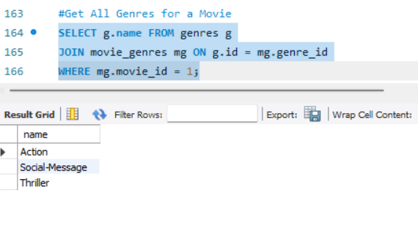

**Get All Reviews for a Movie:**

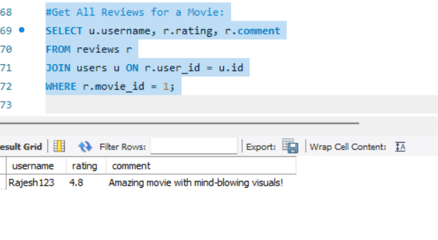

**Get All Skills for an Artist**

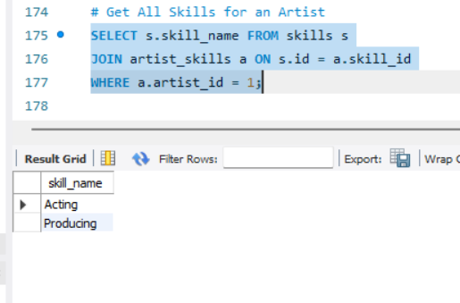

**Get All Roles an Artist Performed in a Movie**

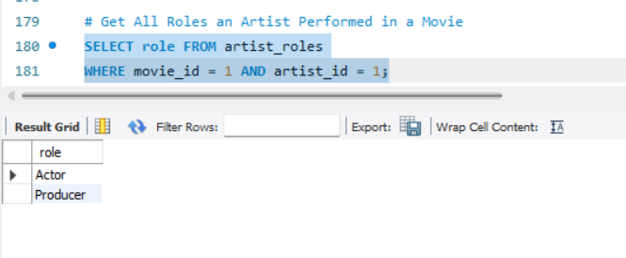

All the tables:

